[Lab-Python] Your First Script

# Summary:

You will create your first basic Python script.

# Creating the script:

1. Create the script in a text editor (Open a new file in nano):

|  |
| --- |
| root@kali:~# nano scriptname.py |

1. Edit the script in nano:

Note: For now just do the text between the “”” and “””. We will study what that is for in a later discussion.

|  |
| --- |
| #!/usr/bin/env python3  “””  prints “Hello World” to the screen  Usage: ./scriptname.py  “””  print(“Hello World”) |

1. Save the script and exit nano:

To save press

* **<Ctrl+o>** then **<Ctrl+x>**

Note: If you forget the pattern look at the bottom bar of the nano editor



1. Give the script permission to execute

* u+x - add eXecuting permissions to the current User

|  |
| --- |
| root@kali:~# chmod u+x scriptname.py |

1. Run your script

|  |
| --- |
| root@kali:~# ./scriptname.py |

# ToDo:

Create your own script called week2-script.py:

## Print out your first and last name

## Print out one thing you learned about Python in this module

Using the git commands you learned in the previous lesson, add, commit and push your changes to your GitHub repository.

Submission:

When you have completed your script and tested that the output matches the directions above, add, commit and push your changes to GitHub. It’s always a good idea to check that your files/changes uploaded to GitHub correctly, by looking at them in GitHub with your browser.

Create an Issue in GitHub to signal you are ready for grading:

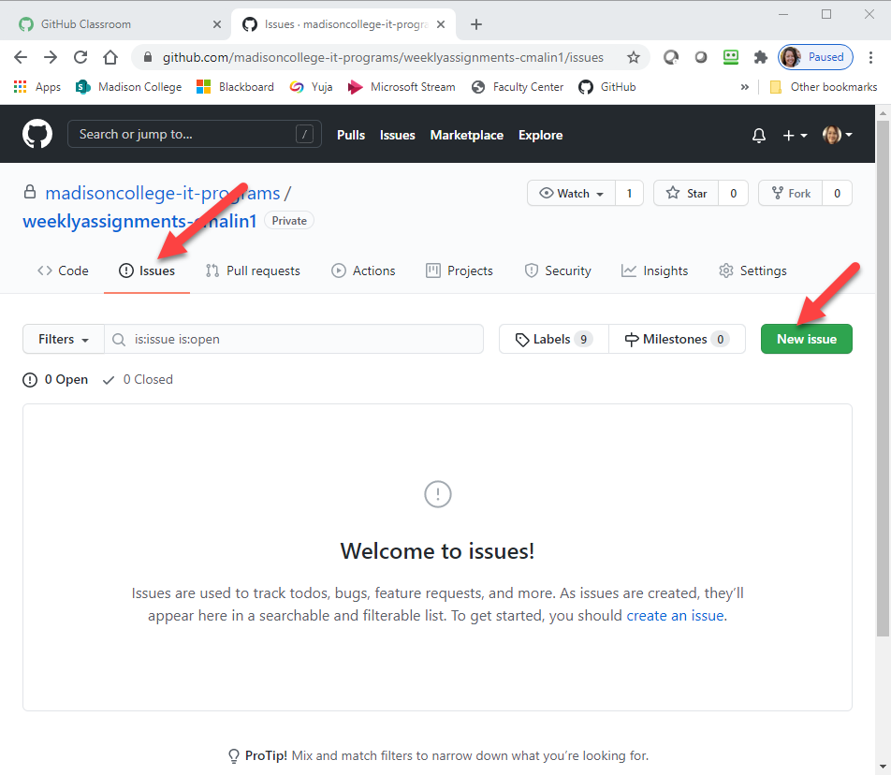

Give your issue a meaningful title and include any comments about things you want specific feedback on or questions you may have about the assignment.

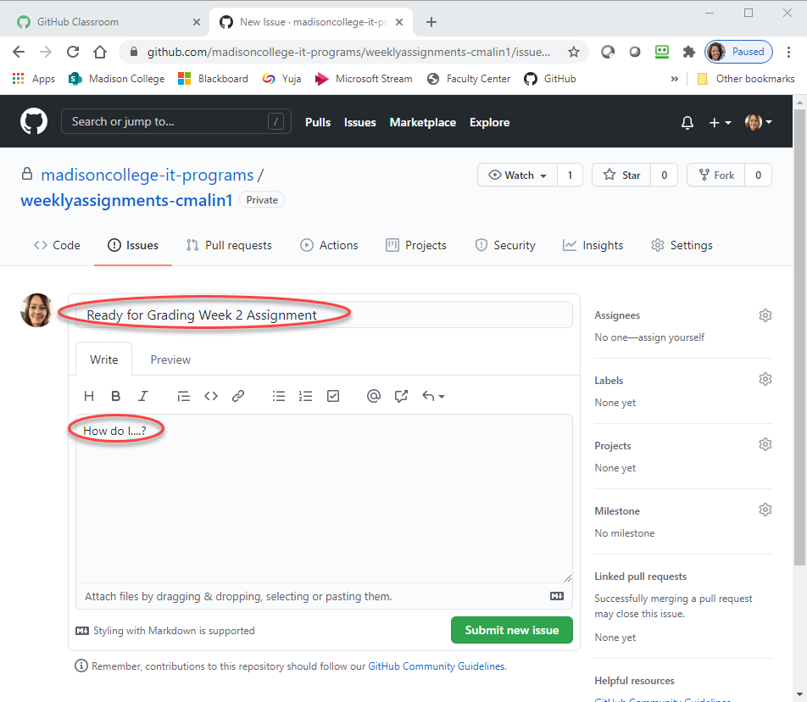

Your instructor will provide feedback in GitHub and post your grade in Blackboard.